Geometry Revsion
Read the following descriptions of some logos and then draw the logo. (USE A RULER)
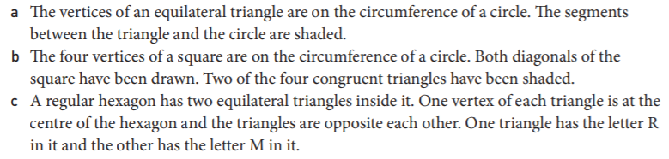

Scale Drawing revison so far with worded questions
1. | 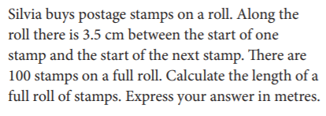
2. | 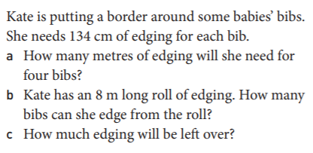
3. | 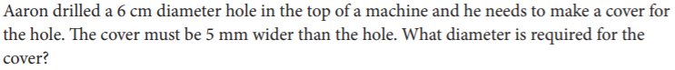
4. | 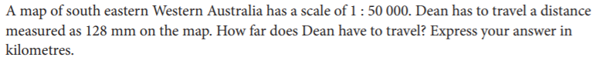
5. | 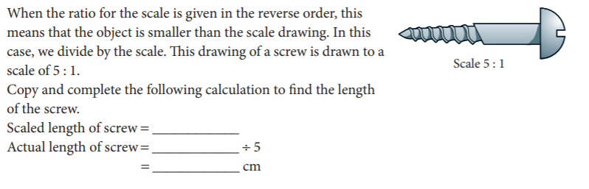

Solutions:

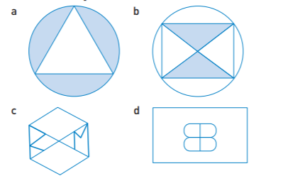

- 3.5m
- A) 5.36m; B) 5 bibs; C) 130cm or 1.3m
- 7cm
- 6.4cm
- Scaled length of screw= 4cm; Actual length is 4/5=0.8cm

